Exercise – Product Registry

1. Objectives

The objectives of this exercise are to practice with the following:

* 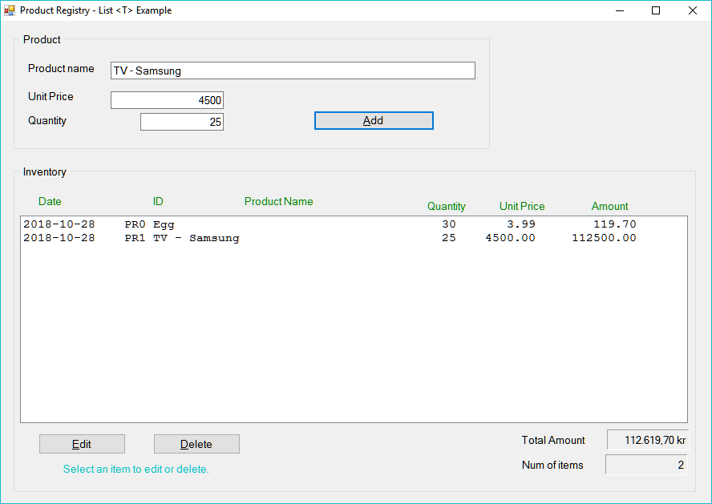Encapsulation
* Collection of the type List < T >

1. Description

Write an application that maintains and handles a list of products.

The input to the applications is:

* Name of product (string)
* Unit price (double or decimal)
* Quantity (int) number of the items available in the inventory.

Output: as shown in the example

* A list of the available items.
* Total amount.

Features: Add a new item, edit or delete an existing item.

1. 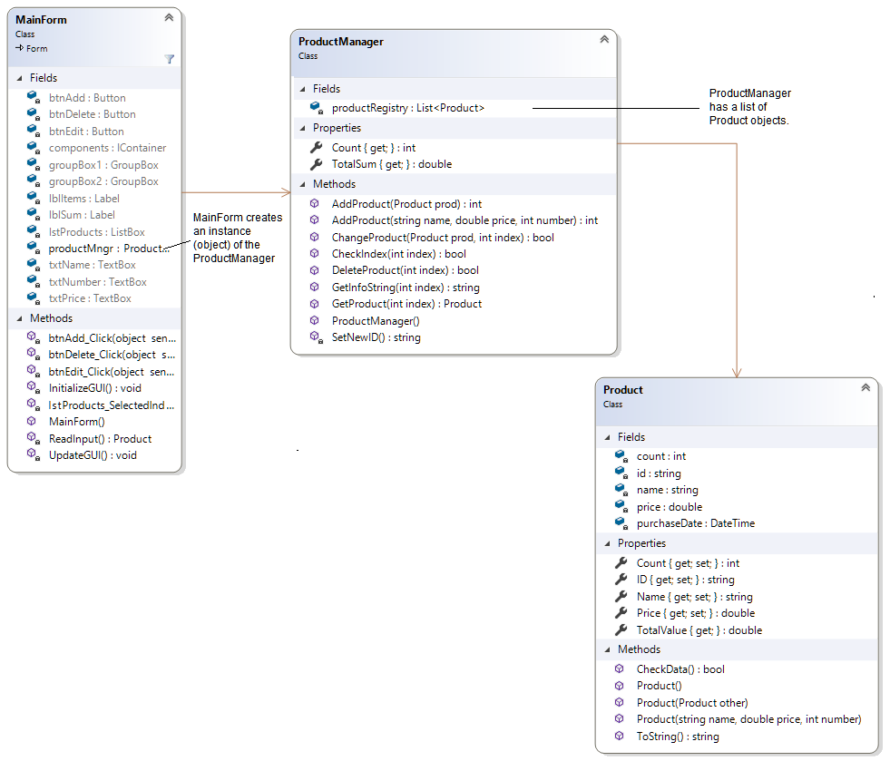Instructions

A class diagram and a file list are for a suggested solution is given below. The code for the solution is available for download in the module.

* 1. Make sure that you validate the user input.
  2. Let only the MainForm talk to the user – no message or other types of interaction should occur in any other class.
  3. Document your code
  4. Do things in steps and then compare to the given solution.

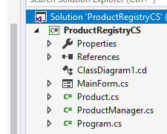

Good Luck!

*Programming is fun. Never give up. Ask for help!*

Farid Naisan,

Course Responsible and Instructor